EXAMPLE MECHANICAL, LLC
DAILY CONSTRUCTION REPORT
Project: Sample Elementary School HVAC Replacement | Owner: Sample ISD
Report No.: DCR-2026-0310 | Dates: Tuesday, March 10 and Wednesday, March 11, 2026
Contract: Project 2026-0001, Job J-0001 | Substantial completion target: May 29, 2026
Prepared by: Pat Doe, Project Manager

Weather | Temperature | Precipitation | Weather Delay
Clear both days | Mild | None | None
GENERAL CONDITIONS
Two productive field days. On March 10 the crew opened the curbs at RTU-1 and RTU-2 and found deteriorated deck at the RTU-1 opening; the curb set at RTU-1 is on hold pending the engineer's direction. The OAC meeting was held that afternoon. On March 11 the engineer walked RTU-1 and gave verbal direction for a deck repair, written direction to follow. RTU-2 curb work continued. No lost time either day.
1. SUMMARY (DAYS AT A GLANCE)
- March 10: curbs opened at RTU-1 and RTU-2. Deteriorated deck found at the RTU-1 opening; curb set at RTU-1 held.
- March 10: weekly OAC meeting held with the owner and engineer (minutes filed separately).
- March 11: the engineer walked RTU-1 and gave verbal direction for a deck repair; written direction to follow.
- March 11: RTU-2 curb adapter set and roofed in.
2. TRADES / PARTIES ON SITE OR ENGAGED
Trade / Party | Activity | Day
HVAC (Contractor) | PM both days: curb openings, deck condition at RTU-1, OAC meeting, coordination with the engineer | 3/10, 3/11
Roofing | Opened roofing at RTU-1 and RTU-2; roofed in RTU-2; weatherproofed RTU-1 at day end | 3/10, 3/11
Electrical (Sample Electric) | Jordan Lee: verified disconnect locations at RTU-1 and RTU-2 | 3/11
Engineer (Sample Engineering, Inc.) | Alex Poe: OAC meeting; site walk at RTU-1 | 3/10, 3/11
Owner (Sample ISD) | Sam Roe: OAC meeting | 3/10
3. RTU-1 DECK CONDITION (PCO-001)
- The deck at the RTU-1 opening is deteriorated along one side and will not support the new curb as is.
- The engineer gave verbal direction on March 11 to add support steel and replace the affected deck section. Written direction to follow.
- Notice of concealed condition sent to the owner and engineer per the contract. PCO-001 will follow with a full breakdown.
4. OAC MEETING (3/10)
- Weekly owner, architect/engineer and contractor meeting held on site.
- RFI-001 (start-up and commissioning sequence) is with the engineer for response.
- Full minutes are filed separately.
5. SCHEDULE
- The RTU-1 deck repair now gates the RTU-1 unit set. RTU-2 remains on schedule.
- Weather is tracked separately for any time only (no cost) extension.
6. SAFETY
- No incidents, injuries, or near misses reported either day.
- Open curbs covered and weatherproofed at day end. Roof edge protection in place.
7. LOOK AHEAD
- Receive written direction from the engineer for the RTU-1 deck repair, then submit PCO-001.
- Confirm the duct transition order with Sample Supply.
- Set RTU-2 and reconnect power, controls, gas and condensate.
8. FIELD PHOTOS (KEY)
 | 
RTU-1 curb opening showing the deck condition. 03/10/2026. | Deck area marked for repair at RTU-1. 03/11/2026.

 | 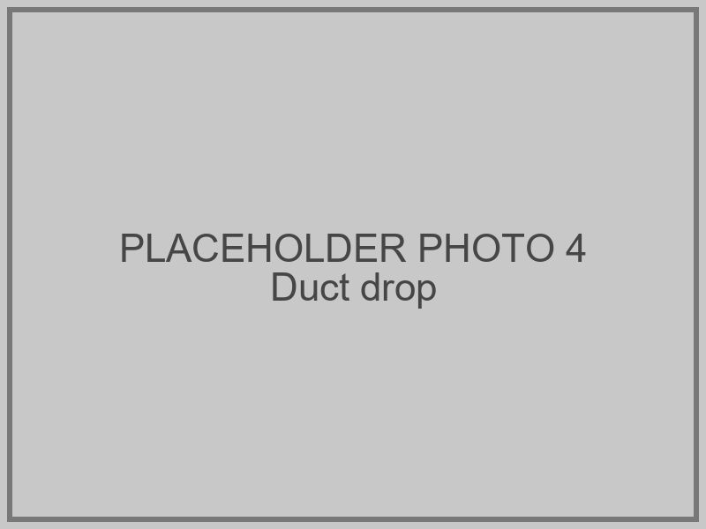
RTU-2 curb adapter set and roofed in. 03/11/2026. | Existing duct drop below RTU-2 before transition fit. 03/11/2026.

9. ATTACHMENTS
- Daily Photo Log, 03/10 to 03/11/2026.
- OAC Meeting Minutes, 03/10/2026.

Prepared by: | Date:
Pat Doe, Project Manager  Example Mechanical, LLC | March 11, 2026

